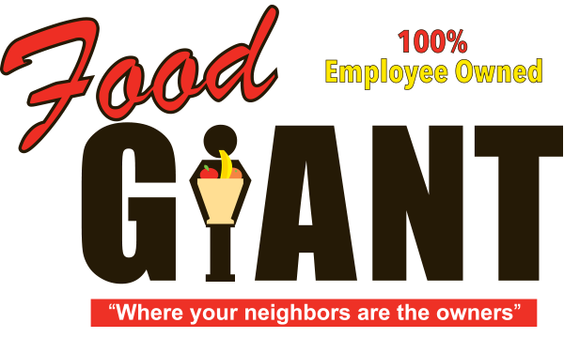

**COT 6931 Final Report**



Food Giant Sales Flyer Generator

**Student - Kendrick Hagerman**

**Client - John Webb**

**Date: 8/2/2017**

Contents

Acknowledgements 2

Project Summary 2

Main Body of Report 3

Project outputs and outcomes 3

How did you achieve the outputs and outcomes? 3

What did you learn? 3

Conclusions 4

Recommendations 4

References 4

Terms of Reference 5

# Acknowledgements

This project report was developed thanks to my client, John Webb, how provided me with a problem that I could solve for my Capstone, and provided me documents and pictures I would use for my layout. Also, this document was completed using documentation from the University of West Florida

# Project Summary

This project is for the Food Giant Supermarket company. The project’s objective is to earn more revenue for the store and reduce the cost of eliminating excess inventory before it loses the company income by becoming expired goods. This will be accomplished by creating a Graphical User Interface (GUI) program designed for District and Store Managers of the company. This program, named the Food Giant Flyer Creation program, will allow these Managers to generate customized flyers specifically for their store that they can print and distribute to customers. These flyers will contain information like the sale dates, store location, store phone number, and a list of items complete with their sale price. Currently, they have no way to create flyers in this fashion. Currently, the only way customers can find out about store-specific sales is to be at the store. These custom flyers will allow a store to more easily reach and inform their customer base about sales, which should draw in more customers, potentially increasing revenue. Finally, this program will be designed for Managers with very little experience with computers.

# Main Body of Report

## Project outputs and outcomes

The project is designed to allow a Manager to output a customized flyer based on one of many flyer templates. This flyer will contain one to fifteen user-selected items consisting of the item name, price, description, and an image of the product. This flyer will be savable as a Portable Document Format (PDF) or printable to a standard 8 1/2 by 11 (standard sheet) paper. The item name and image will be stored and read out of a SQL database. The project will also allow a Manager with appropriate permissions to enter in new store items into the SQL database.

The implementation/testing phase of the project’s outcome ended with multiple deliverables. These deliverables are: The Release version of the source code, a Test Results document, a schedule for the project (ending in August), a Coding Standards Document, a Software Test Document (STD), a Risk Management Document and a Software Requirement Specification (SRS). I also created a PowerPoint and YouTube presentation demonstrating my program.

## How did you achieve the outputs and outcomes?

I used my design document, Software Requirements Specification, and schedule as my roadmap during implementation on my project. I turned the SRS items into User Stories and estimated which ones I complete every two weeks. Then, I worked on implementing the User Stories using Visual Studio. I made my commits with Git Extensions and linked my SRS items to each relevant commit. Once I started working on items, I also updated my test cases in my test cases documentation I generated last semester as well and added more detailed test steps to them, which were tested once the requirement was complete. I repeated these steps each sprint until my backlog items were complete, then re-ran all my tests again on my Virtual Machine (my customer environment) to verify I did not break a previous feature by implementing a new feature.

## What did you learn?

I learned a good bit more into working with Blend on UI design, and figured out some smarter ways to organize my classes in a MVVM paradigm. I also got to work with Azure and learned various techniques like: how to create machine images that can be redeployed onto new Virtual Machines when needed, setting up domain accounts and linking them to virtual machines and how to deploy ASP.Net applications as a web application. I hope to implement the last item in a new project shortly after completing my masters to further my understand with Web Applications.

I kept a log of lessons learned as I worked on the project, which was an idea I realized I should use during my last semester. Here is a list of items that then leads to my overall conclusion of the project:

1. Should have spent more time prototyping flyer item design in Blend, was missing details on how items should look. This wasn’t time consuming to figure out, but sketching a picture in the design document would have helped. Much of implementation was trying to get an aesthetically pleasing look, which is harder to estimate that just functionality.
2. Flyer History table required 4 new columns to achieve functionality. Missed updating the database section of design document after this decision was made. Should make sure to perform regular read throughs of my design document every time a major design decision was made, or every week just to validate my design is still current.
3. Might be worth trying to do more context sensitive actions, like deactivating all other text boxes until user fills out initial fields. This includes input validation, like only allowing the employees to enter in certain values into text boxes. This may improve the users’ comprehension of the program’s operations. This issue is being offset with User Manuals, but should be discussed with stakeholders further.
4. Spent a good bit of effort learning Azure and setting up a reusable machine image. There’s more effort I could spent in making the Azure domain services more accessible to the customer, after providing them some basic training.

# Conclusions

Overall, I feel like using pen and paper or Visio early on to show the customer a physical copy of a basic design could have helped. I would update my design documentation to remind myself of this in the future. I would also like a tighter connection with all my customers and would like to expand on letting them see my design via the internet to make up for distance between us. I feel like I should have spent another 2-week Sprint just learning Azure and delivering a sample Virtual Machine connection demo to my stakeholders to help them understand how they will access the application.

I feel like I satisfied my customers’ requirement for this Capstone project, but there is still more work that can be done once they use the program more. I believe it was a good idea to accept this project since I could gain experience performing estimations of software requirements and create a schedule on how to complete these requirements.

# Recommendations

Please see the references for website links I would recommend looking at for more information.

# References

Microsoft. *The MVVM Pattern.* 2017 <https://msdn.microsoft.com/en-us/library/hh848246.aspx>

Caliburn Micro. *Caliburn.Micro Xaml made easy.* 2017 <http://caliburnmicro.com/>

Azure Virtual Machines. Microsoft. 2017. <https://docs.microsoft.com/en-us/azure/virtual-machines/windows/index>

## Terms of Reference

|  |  |
| --- | --- |
| Term | Definition |
| ASP.NET | Active Server Pages |
| ASPX | Active Server Page Extended |
| C# | C-Sharp Programming Language |
| GUI | Graphical User Interface |
| MVVM | Model View View-Model |
| QA | Quality Assurance |
| SDD | Software Design Description |
| SLN | Visual Studio Solution |
| SPMP | Software Project Management Plan |
| SQL | Structured Query Language |
| SRS | Software Requirements Specifications |
| STD | Software Test Document |
| VS | Visual Studio |
| XAML | Extensible Application Markup Language |